HotStorage 2026 Attend Page

Section 1: Introduction
Q: Does this section stay the same apart from the grant deadline dates?
Q: What are the 2026 grant application deadline and results-notification date?
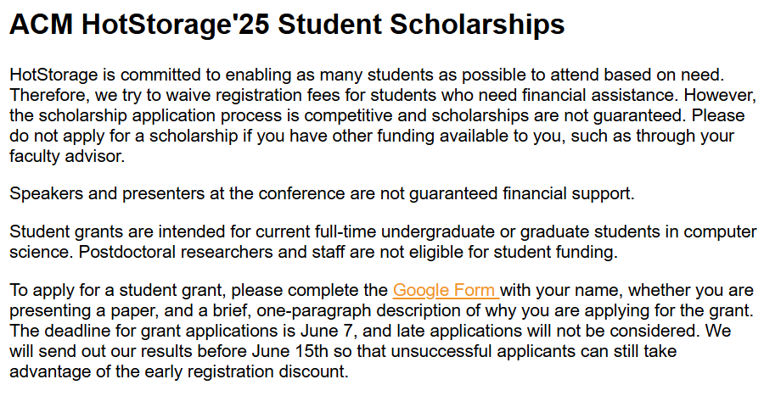

Section 2: Registration
Q: Do we keep the professional-membership tabs highlighted in red below, or remove/replace them?
Q: Registration link will point to the SOSP'26 registration page: https://web.cvent.com/event/cdb96216-ab5e-4a4b-9705-0904c9fa2e26/summary — please confirm this is correct.
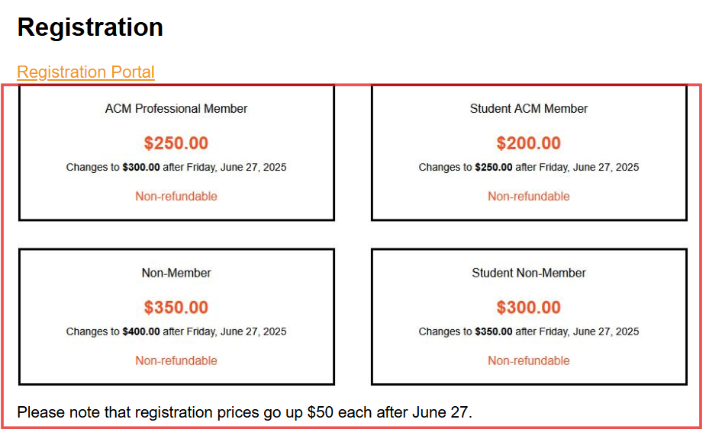

Section 3: Visa
Everything in this section stays the same; only the dates, venue, and the "HotStorage26" label will be updated. Please confirm.
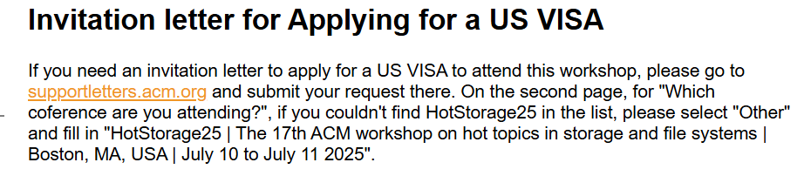

Section 4: Venue
Q: What is the confirmed 2026 venue (name, address)?
Q: Is there a reference document/link with the venue details we should use?

